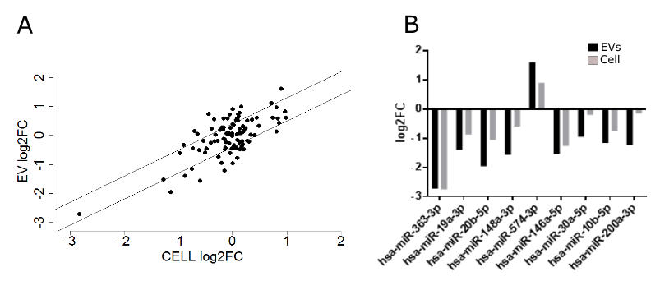Fig. 1: Cavin-1 expression modifies selective export of specific microRNA species. A) Cellular and EV miR content modified upon expression of cavin-1. RNA-seq experiment was performed on small RNAs extracted from GFP-PC3-EVs and cavin-1-PC3-EVs and whole cell lysates. Points on the correlation graph represent the mean log2 fold change of RNA species (n=95) upon cavin-1 expression. Lines roughly approximate the 95% confidence intervals of a linear regression. MiRs outside of the CI are considered selectively exported. B) MiRs significantly (p≤0.05) modified within the EVs upon cavin-1 expression where closer examined to determine selective export. Log2fold change for cell (grey) and EV (black) for each interesting miR was plotted and compared with a Mann-Whitney U-test.

Fig. 2: Confirmation of selective miRNA export upon cavin-1 expression. RT-qPCR measured cDNA synthesised from total RNA from GFP-PC3 cell, cavin-1-PC3 cells and the EVs derived from these cells. Bar graphs represent the normalised change for each miR between the cell lines. Mann Whitney U-test was used to determine significant change.

Fig. 3: Exported miRs contain specific motifs that correlate to sorting. A) TAMO software suite was used MEME algorithm to identify stretches of nucleotides shared within the selectively exported miRs. These motifs are expressed as a sequence logo. B) Position of the motifs overlaps with the seed region.

Fig. 4: Exported RNA-binding proteins may mediate miR export. Mass spectrometry was completed to determine the proteomic content of EVs from GFP-PC3 and cavin-1-PC3 combined with gene ontology assessment to determine RNA binding capabilities. Venn diagram represents number of proteins that correspond to each criteria. 5 proteins fulfil both criteria and may be candidate miR export proteins.

Fig. 5: hnRNPK changes subcellular localisation from vesicular localisation to endoplasmic reticular in cavin-1 expressive cells.

Fig. 6: hnRNPK co-localizes with selectively exported miRs and not non-selective miRs.